10 Cm Distance from Grille

Figure Anemometry 10cm from grille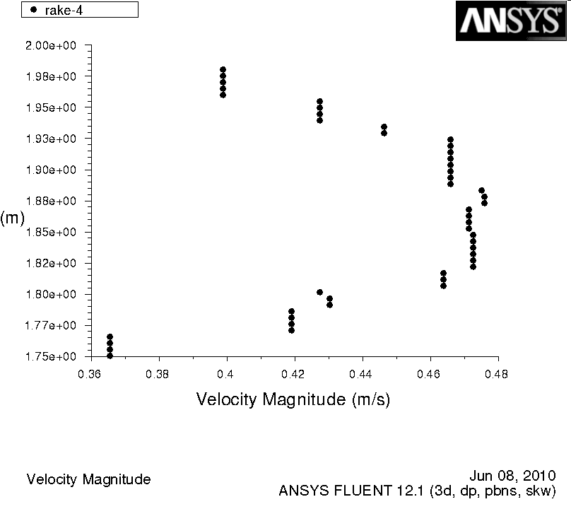

Figure Tet 0.05, 10cm from Grille 46cells/pts